**Faculty of Engineering**

**SCHOOL OF INFORMATION TECHNOLOGY**

**B.Tech. IT VI Semester**

**IT3201 AIML**

**Assignment -2**

Q.1 Define Machine Learning. Why we need machine learning? Discuss the classification of machine learning with example and discuss various applications of machine learning.

|  |  |  |  |  |
| --- | --- | --- | --- | --- |
| x | 2 | 4 | 6 | 8 |
| y | 3 | 7 | 5 | 10 |

Q.2 Define ANN. What is Regression Analysis? Find linear regression equation for the following two sets of data:

Q.3 Explain the Candidate Elimination algorithm. Consider [the weather data on the days our friend Aldo enjoys (or doesn’t enjoy) his favourite sport](http://www.cs.cmu.edu/~tom/mlbook.html):

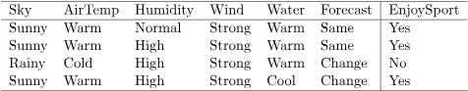

Use Candidate Elimination algorithm on the above dataset.

Q.4 Define Perceptron with its types. Explain the multi-layer perceptron learning algorithm.

Q.5 Assume that the neurons have a sigmoid activation function performs a forward pass and a backward pass on the network. Assume that the actual output of Y is 0.5 and learning rate is 1. Perform another forward pass.

